Vue.js for Frontend Development
Exploring Vue.js framework for frontend development

Tanur Rizaldi Rahardjo - 13519214
Program Studi Teknik Informatika
Sekolah Teknik Elektro dan Informatika
Institut Teknologi Bandung, Jalan Ganesha 10 Bandung
E-mail : 13519214@std.stei.itb.ac.id

Abstract—Vue.js is relatively new and simple javascript framework. Compared to other javascript framework like AngularJS or Svelte, Vue.js have lower learning curve and more lightweight due to Vue.js modular approach. Vue.js use inspiration from React & AngularJS and compress them into simpler package. This paper will explore Vue.js framework for Frontend development generally and real implementation in PPL course.
Keywords—Vue.js; Javascript; Frontend; Framework; Exploration

Introduction
Javascript, a programming language that created for fulfilling purpose of client-side logic on web page. Before javascript is created, a web page only consist of plain HyperText Markup Language (HTML) which will be shown to end user as simple static page.
HTML only contain simple information and document hierarchical structure which will be parsed into static Document Object Model (DOM). Those structure on HTML-only page will only used for page layouting purpose. Browser will try to use document layout information and render it to end user screen.
As Internet gaining popularity very-very quickly, needs for page interactivity quickly becoming main priority. Static web page could be designed to hyperlink each other and using single-use form for simulating interactivity, but it also getting tedious really fast and very easily break during maintenance. First graphical user interface web browser, Mosaic, developed and owned by Netscape corporation developed scripting language and HTTP cookie for client-side logic and user interactivity.
Usefulness of javascript and HTTP cookie caused other browser to follow and implement them in their respective browser engine. To this day, both technology still fundamental for frontend development. Client-side logic and state handling allow a web page for wider range of user interactivity and more complex web page.
As Internet getting more and more mature, a lot of feature from one site reused to other site and more complex feature also require complex state handling on javascript. Slowly, frontend developer decided to create a framework that designed for simpler component reusability and state handling. Javascript framework allow more frontend developer to focus on implementing end user interface and feature rather than creating their own complex state handling and component system.
Some technology corporation also create their open source javascript framework developed in-house such as React by Facebook and AngularJS by Google. Both framework are still widely used, but both framework have relatively steep learning curve, especially toward new frontend developer. Most of javascript framework add a lot of built-in and already strapped into core framework without option to exclude them. On top of that, those framework also add even more complexity by extending javascript to superset language like jsx.
A Google employee, Evan You, decided to create another framework with simplicity in mind. Taking inspiration from several feature of other framework like React and AngularJS, Vue.js core framework only contain several critical component like state handling and put other feature on package which can be included incrementally. Vue.js project use extension .vue which only HTML, plain javascript, and css in single package. Vue.js do extend HTML and javascript with several core feature like conditional rendering and state mutation. Syntax extension is relatively smaller and simpler compared to other framework. Simplicity of Vue.js is its main strength and loved feature among frontend developers.

Exploration and Analysis

Using Vue.js for PPL course project
Due product owner requirement, the project need to use Vue.js + Tailwind for frontend and Laravel for backend. Product owner describe the project as assets management system. For device accessibility purpose, product owner pick web application rather than native application. Due relatively simpler backend logic, backend only need one developer to handle it, rest of the team will be allocated for frontend developer. I was allocated for frontend development. As this is my first experience in frontend development with some kind of javascript framework, I kind of bit scared of getting overwhelmed by steep learning curve. Only my previous frontend experience is plain HTML and javascript.

First sprint focused on UI/UX design using Figma. Here few sample of designed page

- History page


- Home page
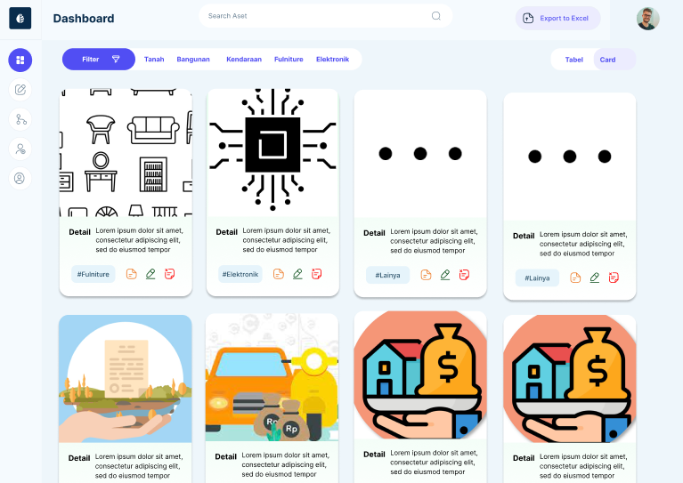

On second sprint, both backend and frontend development are started. I assigned for gluing together homepage with other component. I have to learn both Vue.js for state management & logic and Tailwind for layouting. As project goes, more and more component and view added to the project. Here is end result of views in project



Surprisingly for first project experience with Vue.js, directories in end result relatively clean and still comprehensible.

Analysis
Personal experience from someone who never use javascript framework before, Vue.js is very simple and straightforward. To my surprise, the one that took longer to learn is Tailwind due enormous list of utility class. Vue.js is very straightforward for someone already familiar with plain HTML-javascript and general programming. For example, Vue.js allow conditional rendering on HTML

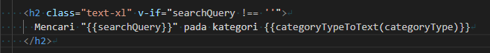

{{variable}} allow HTML to show text data reactively. v-if only render HTML object if condition is true, a very basic control flow is easily added to HTML and readable. Vue.js also allow developer to create arbitrary component

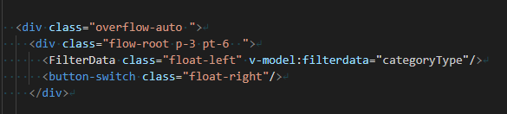

Above is example of using component in Vue.js. FilterData is self-created component that reusable in any view or even other component. Parent view can pass data to component using v-model or v-bind. Child component can send information back to parent by using $emit.

Conclusion
I conclude Vue.js is very accessible javascript framework even for new frontend developer. Vue.js limit complexity by simply gluing HTML, javascript, and CSS together in single file and use very straightforward syntax for basic operation. Developer also still use javascript and HTML method, ignoring Vue.js if they want. By incremental complexity, Vue.js complexity also only gradually increase as developer need more complex operation.

References
[1] https://developer.mozilla.org/en-US/docs/Learn/Tools_and_testing/Client-side_JavaScript_frameworks/Introduction
[2] https://vuejs.org/tutorial/

